Task 1. Database Modelling
Design an E-Commerce Database Model
- Develop a data model suitable for an e-commerce application that includes at least three entities.
- Your model should clearly show the entity names and attributes for each table.
- Your model should clearly show primary keys and foreign keys, where appropriate.
- Your model should clearly show the relationships between tables (one-to-one, one-to-many, many-to-many), indicating how they connect and enforcing referential integrity.

Please find below screenshots and scripts for creating the data model.

Creating Schema:
The schema for ‘ecommerce_db’ is created using the command below.

CREATE SCHEMA `ecommerce_db` ;

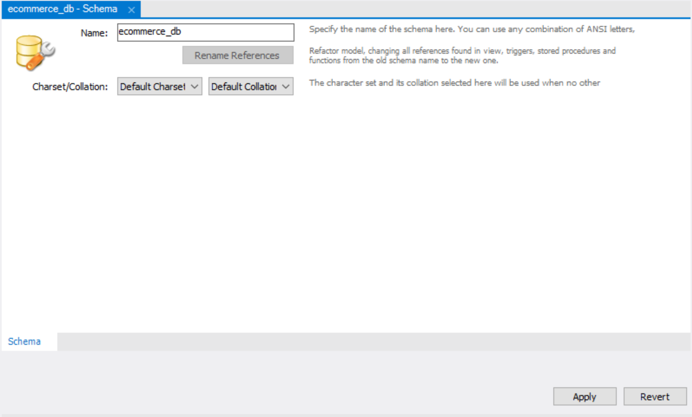

Creating customers table:
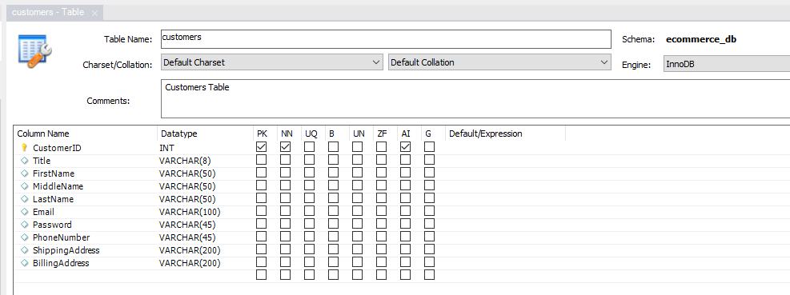

CREATE TABLE `ecommerce_db`.`customers` (
`CustomerID` INT NOT NULL AUTO_INCREMENT,
`Title` VARCHAR(8) NULL,
`FirstName` VARCHAR(50) NULL,
`MiddleName` VARCHAR(50) NULL,
`LastName` VARCHAR(50) NULL,
`Email` VARCHAR(100) NULL,
`Password` VARCHAR(45) NULL,
`PhoneNumber` VARCHAR(45) NULL,
`ShippingAddress` VARCHAR(200) NULL,
`BillingAddress` VARCHAR(200) NULL,
PRIMARY KEY (`CustomerID`))
COMMENT = 'Customers Table';

Creating products table:
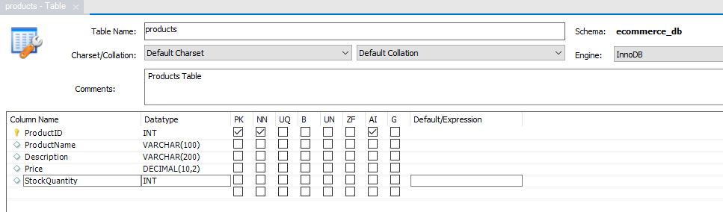

CREATE TABLE `ecommerce_db`.`products` (
`ProductID` INT NOT NULL AUTO_INCREMENT,
`ProductName` VARCHAR(100) NULL,
`Description` VARCHAR(200) NULL,
`Price` DECIMAL(10,2) NULL,
`StockQuantity` INT NULL,
PRIMARY KEY (`ProductID`))
COMMENT = 'Products Table';

Creating orders Table:
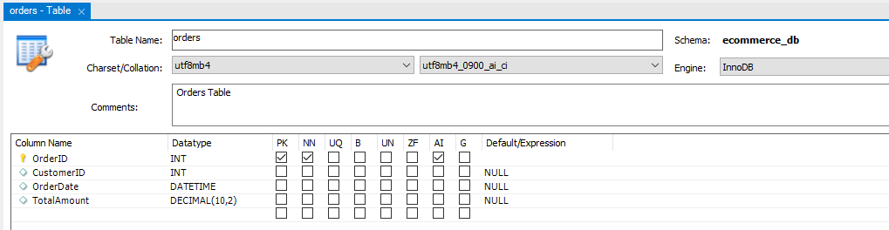

CREATE TABLE `ecommerce_db`.`orders` (
`OrderID` INT NOT NULL AUTO_INCREMENT,
`CustomerID` INT NULL,
`OrderDate` DATETIME NULL,
`TotalAmount` DECIMAL(10,2) NULL,
PRIMARY KEY (`OrderID`))
COMMENT = 'Orders Table';

Creating orderdetails Table:
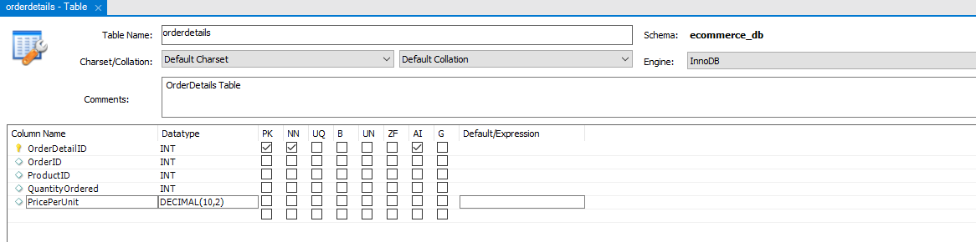

CREATE TABLE `ecommerce_db`.`orderdetails` (
`OrderDetailID` INT NOT NULL AUTO_INCREMENT,
`OrderID` INT NULL,
`ProductID` INT NULL,
`QuantityOrdered` INT NULL,
`PricePerUnit` DECIMAL(10,2) NULL,
PRIMARY KEY (`OrderDetailID`))
COMMENT = 'OrderDetails Table';

Creating shippingdetails Table:
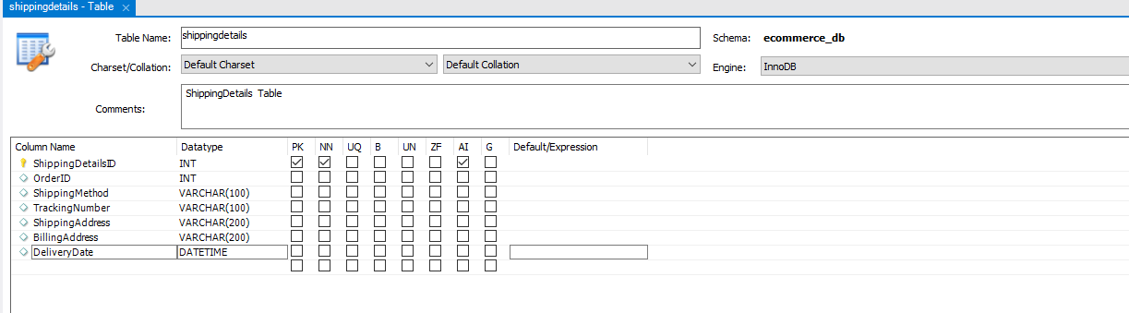

CREATE TABLE `ecommerce_db`.`shippingdetails` (
`ShippingDetailsID` INT NOT NULL AUTO_INCREMENT,
`OrderID` INT NULL,
`ShippingMethod` VARCHAR(100) NULL,
`TrackingNumber` VARCHAR(100) NULL,
`ShippingAddress` VARCHAR(200) NULL,
`BillingAddress` VARCHAR(200) NULL,
`DeliveryDate` DATETIME NULL,
PRIMARY KEY (`ShippingDetailsID`))
COMMENT = 'ShippingDetails Table';

Relationships:
- One-to-Many Relation between ‘customers’ and ‘orders’ tables: One customer can have many orders. But each order entry belongs to one customer only. Hence there is One-to-Many Relation between ‘customers’ and ‘orders’ tables.
A foreign key ‘customers_orders’ is added between orders.CustomerID customers.CustomerID

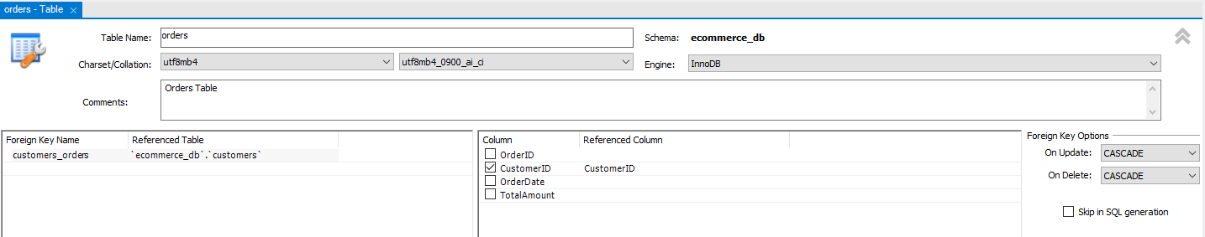

ALTER TABLE `ecommerce_db`.`orders`
ADD INDEX `customers_orders_idx` (`CustomerID` ASC) VISIBLE;
;
ALTER TABLE `ecommerce_db`.`orders`
ADD CONSTRAINT `customers_orders`
FOREIGN KEY (`CustomerID`)
REFERENCES `ecommerce_db`.`customers` (`CustomerID`)
ON DELETE CASCADE
ON UPDATE CASCADE;

- One-to-Many Relation between ‘orders’ and ‘orderdetails’ tables: One order can have many detail records. But one entry in ‘orderdetails’ table refers to one order only. There is One-to-Many Relation between ‘orders’ and ‘orderdetails’ tables.
A foreign key ‘orders_orderdetails’ is added between orderdetails.OrderID orders.OrderID

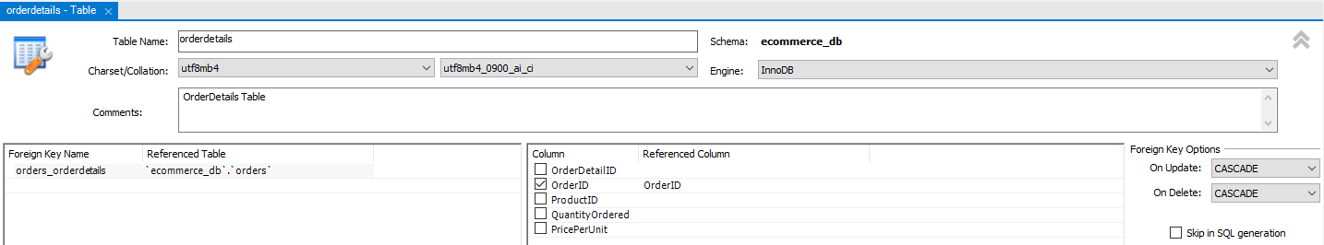

ALTER TABLE `ecommerce_db`.`orderdetails`
ADD INDEX `orders_orderdetails_idx` (`OrderID` ASC) VISIBLE;
;
ALTER TABLE `ecommerce_db`.`orderdetails`
ADD CONSTRAINT `orders_orderdetails`
FOREIGN KEY (`OrderID`)
REFERENCES `ecommerce_db`.`orders` (`OrderID`)
ON DELETE CASCADE
ON UPDATE CASCADE;

- Many-to-Many Relation between ‘orderdetails’ and ‘products’ tables: An orderdetails can contain many products, and each product can be part of many orderdetails. Hence there is Many-to-Many Relation between ‘orderdetails’ and ‘products’ tables.
A foreign key ‘orderdetails_products’ is added between orderdetails.ProductID products.ProductID

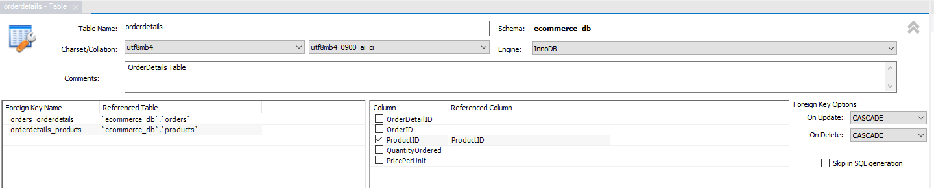

ALTER TABLE `ecommerce_db`.`orderdetails`
ADD INDEX `orderdetails_products_idx` (`ProductID` ASC) VISIBLE;
;
ALTER TABLE `ecommerce_db`.`orderdetails`
ADD CONSTRAINT `orderdetails_products`
FOREIGN KEY (`ProductID`)
REFERENCES `ecommerce_db`.`products` (`ProductID`)
ON DELETE CASCADE
ON UPDATE CASCADE;

- One-to-One Relation between ‘orders’ and ‘shippingdetails’ tables:
One order can have only one shipping details record. And one shipping record can belong to one order only. Hence there is One-to-One Relation between ‘orders’ and ‘shippingdetails’ tables.
Foreign key ‘orders_shippingdetails’ is added between shippingdetails.OrderID orders.OrderID

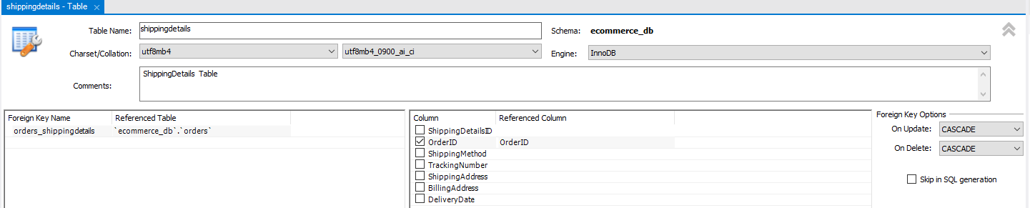

ALTER TABLE `ecommerce_db`.`shippingdetails`
ADD INDEX `orders_shippingdetails_idx` (`OrderID` ASC) VISIBLE;
;
ALTER TABLE `ecommerce_db`.`shippingdetails`
ADD CONSTRAINT `orders_shippingdetails`
FOREIGN KEY (`OrderID`)
REFERENCES `ecommerce_db`.`orders` (`OrderID`)
ON DELETE CASCADE
ON UPDATE CASCADE;

EER Diagram:

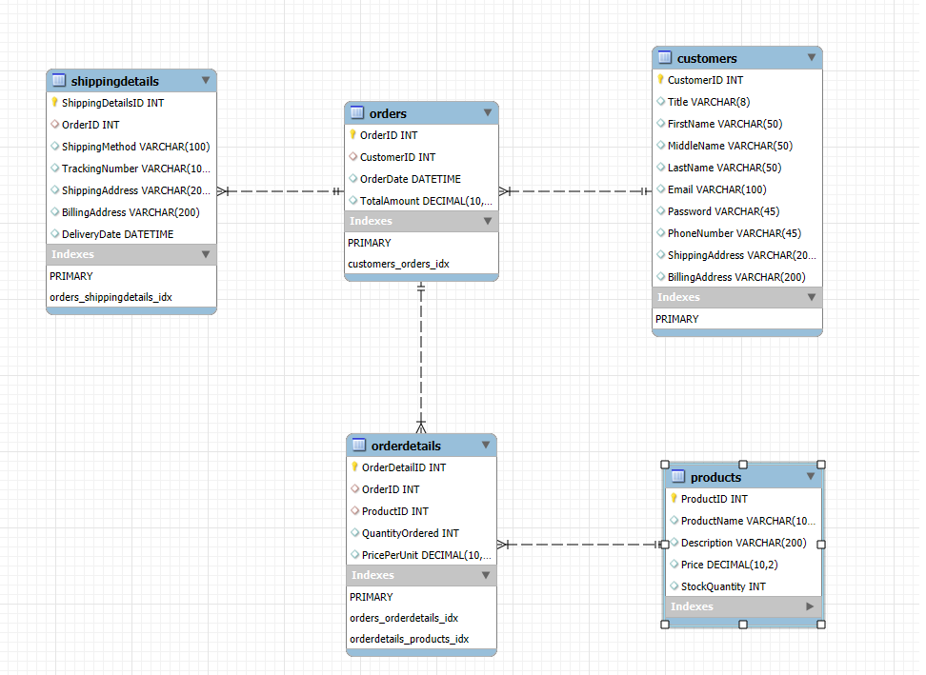

Task 2. Basic SQL Queries: Execute CRUD Operations
Write SQL statements for the following tasks using hypothetical data from a typical e-commerce database:

Please find below screenshots and scripts for the CRUD operations.

a) Insert a new customer record in the Customers table.
Insert Into ecommerce_db.customers (
Title, FirstName, MiddleName, LastName, Email, Password, PhoneNumber,
ShippingAddress, BillingAddress
)
VALUES
(
'Ms', 'Alice', 'Peter', 'Tan', 'alice@gmail.com', 'aabbccdd12345', '98988989', 'Blk - 123 East Coast Road, #06-121, 123123',
'Blk - 123 East Coast Road, #06-121, 123123'
)

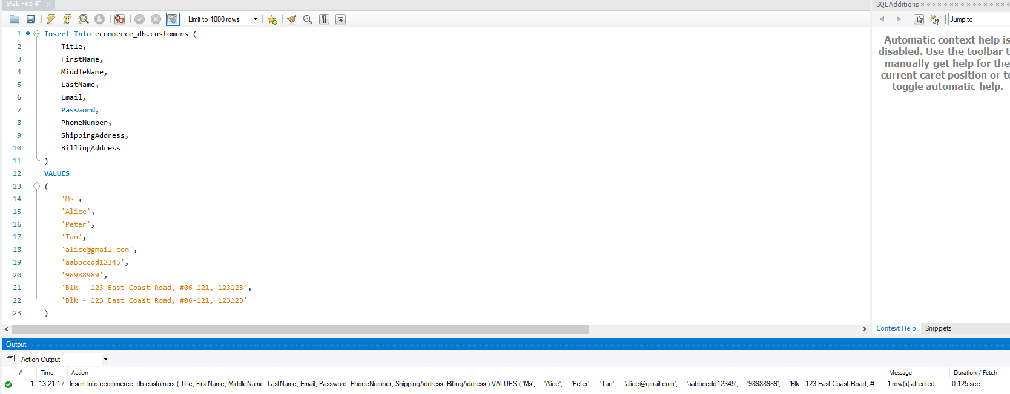

b) Update a customer's email address based on their unique CustomerID.

Update ecommerce_db.customers
Set Email='alice.tan@gmail.com'
Where CustomerID=1

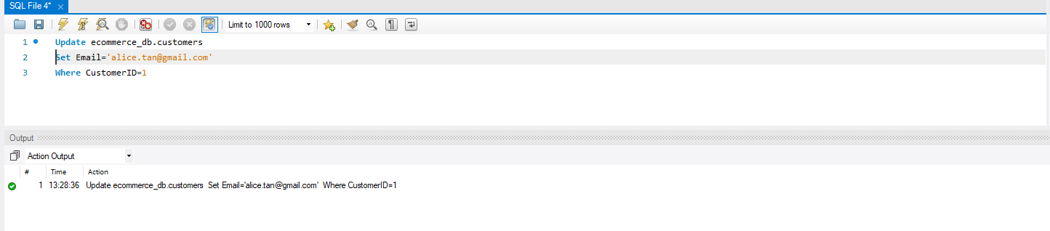

c) Delete a specific record from the Orders table based on OrderID.

Delete from ecommerce_db.orders
Where OrderID=3;

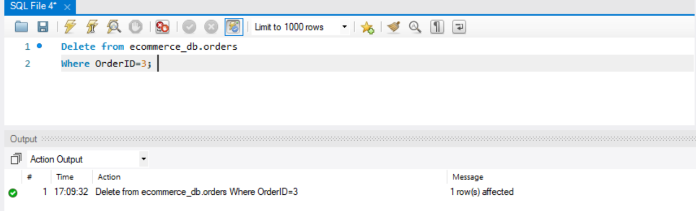

Task 3. Advanced SELECT Queries: Filtered Data Retrieval
Write a SELECT query to fetch all orders from the Orders table that meet the following criteria:
a) Orders were placed in January 2024.
b) The order total exceeds $500.
c) Your query should only include columns for OrderID, OrderDate, and TotalAmount in the result.

Select OrderID,OrderDate,TotalAmount From ecommerce_db.orders
Where OrderDate BETWEEN '2024-01-01' AND '2024-01-31'
AND TotalAmount > 500
Order by OrderDate;

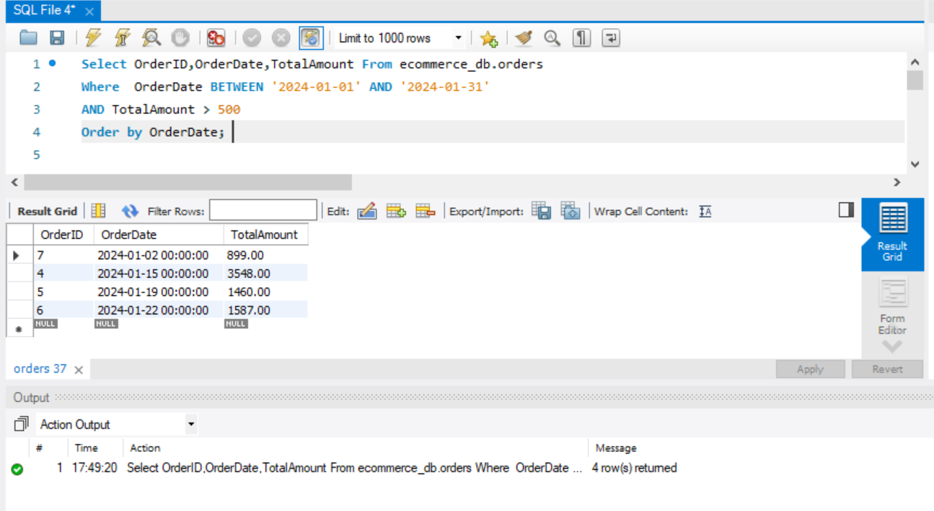

Task 4: SQL Joins for Data Aggregation

Retrieve Information Using Joins
a) Using the tables Products, Orders, and OrderDetails, write an SQL query.
b) The query should retrieve information on products ordered in June 2024.
c) The result should display:
ProductName: The name of the product.
QuantityOrdered: The quantity of each product in the order.
OrderDate: The date the order was placed.

Below script retrieves the Product Name, Sum of Quantity ordered and Order Date, grouping by the Product ID and the Order Date. The June month’s data is retrieved from three different tables a) orders, orderdetails and products.

Select
p.ProductName,
SUM(od.QuantityOrdered) As QuantityOrdered,
o.OrderDate
From ecommerce_db.orders o
Inner Join ecommerce_db.orderdetails od on o.OrderID = od.OrderID
Inner Join ecommerce_db.products p on od.ProductID = p.ProductID
Where
o.OrderDate BETWEEN '2024-06-01' AND '2024-06-30'
Group by o.OrderDate, p.ProductID
order by o.OrderDate;

